Freedom of Road Riders®, Inc.
To promote safety, rider education, brotherhood, and freedom for all motorcyclists.

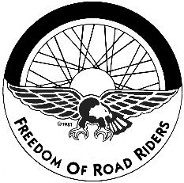
FORR® SAFETY COURSE REGISTRATION FORM
Name __________________________________________
M.I. ________________________
Address ______________________________________________
Phone ______________________
City, State, Zip _________________________________________
Birthdate ____________________
FORR # ______________________
Email_______________________________________
Date of Class Requested ______________________________
Check one:
___BRC $250.00 (for beginning riders & license waiver)
___BRC2 $130.00 (for experienced riders)
___ARC $130.00 (for advanced riders)
___3WBRC $250.00 (for 3-wheel riders)
Full Deposit must accompany this registration form by Check or Money Order.

